Guidance

Stormwater Best Management Practices Performance Evaluation

**NOTE**

This page is a placeholder. The support contractor prepares covers, incorporating standard and team icon graphics.

[December 2018]

Prepared by

The Interstate Technology & Regulatory Council

s. This document then provides links to established testing protocols developed and currently being administered by several agencies across the country, including the Washington Department of Ecology (Ecology) (See Section 2.4.1) , the New Jersey Department of the Environmental Protection (NJDEP); See Section 2.4.2), Oregon Department of Transportation (ODOT) (See Section 2.4.3), the International Stormwater BMP Database (BMPDB; See Section 2.4.4), ) and Stormwater Testing and Evaluation for Products and Practices (STEPP); (See Section 2.4.5). Each of these provide varying levels of information on BMPs as shown in Figure 1-1.

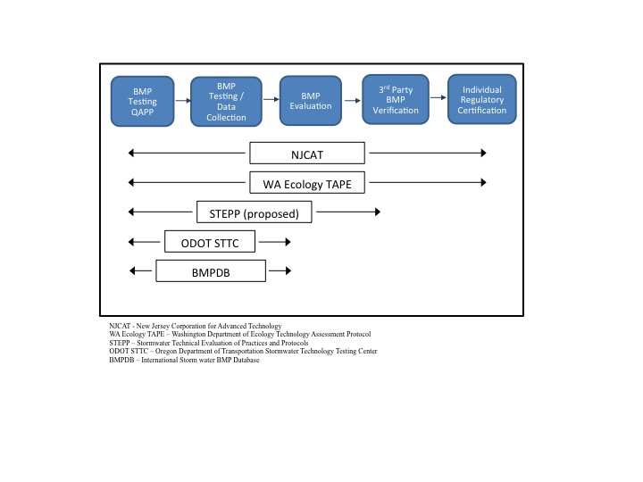

**Figure 1-1. Extent of Coverage of Selected Programs**

### Intended Users

This document is intended to serve as a guidance for the following users during BMP screening, selection, design, installation, operation, and maintenance and monitoring:

* Primarily State and local regulators.
* Secondarily this document will also benefit:
  + Owners and developers;
  + Consultants and engineers;
  + Manufacturers and vendors; and
  + Public and Tribal stakeholders.

State and local regulators may find the content useful in their BMP vetting processes. Owners and developers may consult this guidance to build a case to support regulatory acceptance of non-standard BMPs that are proposed. As many developers are currently limited to selection of approved BMPs listed in design manuals, this document will help broaden the range of structural BMPs that may be considered.

## ITRC SURVEY DESCRIPTION

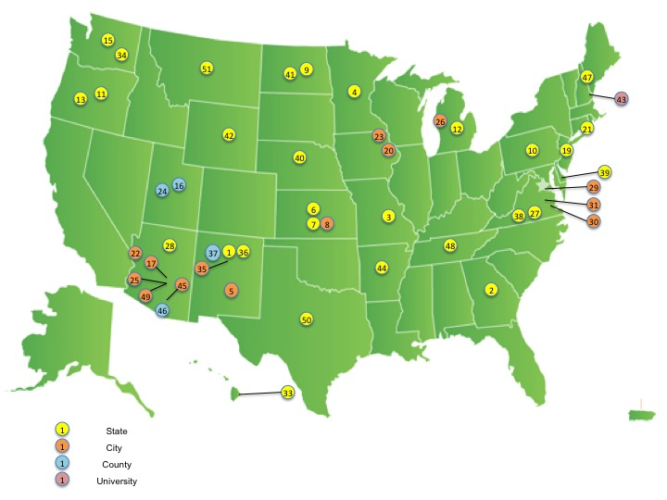  
During development of the guidance and tool,, ITRC distributed a survey to the ITRC State Points of Contact (POCs) in 2017. The survey sought the state and local perspective on stormwater pollutants that require treatment, how performance of the treatment is measured, and how a BMP is monitored and maintained over time. The survey also asked for barriers to implementation of pollutant treatment and maintenance. Each state POC was asked to complete the survey and distribute it to three municipalities. Fifty one responses were received from a mix of cities, counties, states, and universities. The distribution of the responses are shown in Figure 1-2 with a numeric identifier for each of the 51 respondents. While state representation made up a majority of responses, municipal and other representation was valuable where provided.

**Figure 1-2 Distribution of Responses to the ITRC Survey 2017**

The full set of survey responses are provided in Appendix A. Summaries and charts of responses to specific questions are included in related section of this guidance.

## Guidance Document Sections

This Guidance Document is divided into 4 components that represent the programmatic elements of Storm water management control:

* Data Applicability (Chapter 2),
* Screening Considerations (Chapter 3),
* Installation (Chapter 4), and
* Operations (Chapter 5).

A brief synopsis of each element below will allow the user a quick reference to the topic and a direct link if preferred. (Figure 1-3)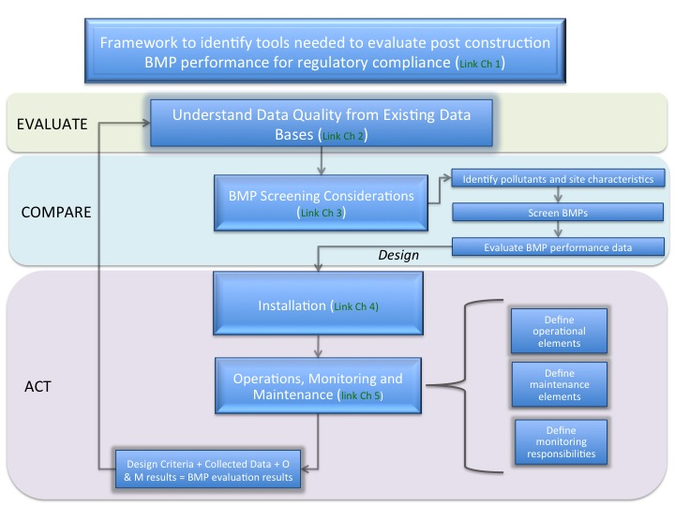

**Figure 1-3. Flow diagram illustrating the elements of this guidance**

### Data Applicability (link to Chapter 2)

The purpose of the data applicability section is to educates users on the availability and quality of BMP performance data. Specifically, this section provides an overview of the major data repositories and BMP evaluation programs, which were currently active at the publication date of this guidance and utilized by the regulatory community in making BMP approval decisions. For completeness, the data applicability section also calls attention to programs that are no longer active but may have produced data that remains viable. Particular emphasis is placed on the Washington State Department of Ecology’s Technology Assessment Protocol-Ecology (TAPE) as well as the New Jersey Department of Environmental Protection’s laboratory protocols and certification process, as a result of their national recognition. A number of other well-known programs and repositories are also included along with insight on how to access and use them. This section also contains a general discussion of BMP performance data collection that explores data quality and quantity objectives, lab and field protocols, and sampling methodologies.

Stormwater sites may impact multiple jurisdictions and stakeholders have proved instrumental in the decision-making process. For example, at Moffett Field, California the US Navy included the Santa Clara Valley Water District as well as the cities of Mountain View and Sunnyvale, but early discussions of wetlands remediation would have proceeded more smoothly if the Mid-Peninsula Regional Open Space District, owner of a large fraction of the federal stormwater retention pond, had also been involved in discussions. The Mid-Peninsula Regional Open Space District had the site knowledge. Few local governments have the technical expertise to ask planning and implementation questions, which answer such questions on their own.

[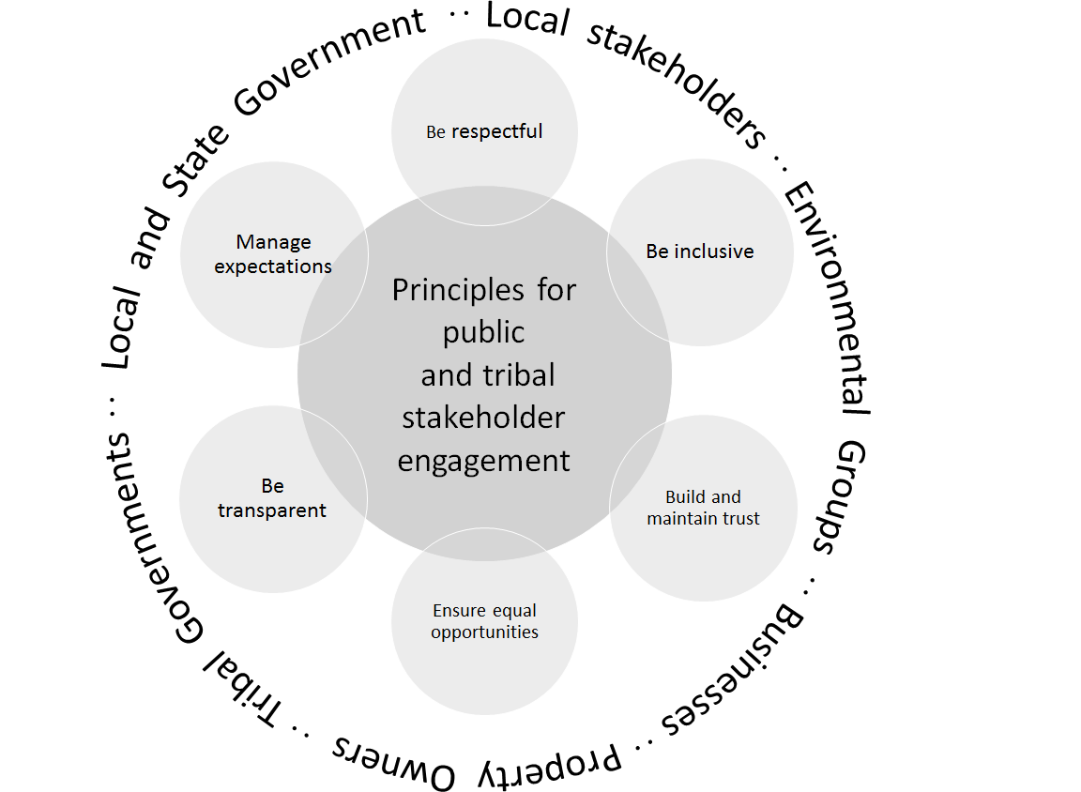](http://www.fpc.wa.gov.au/sites/default/files/Stakeholder%20engagement%20diagram.png)

## Existing Data Verification Programs

Table 2-1 includes general information on the five existing programs discussed in this section. The table includes summary information with additional detail in the separate sections, below.

|  |  |  |  |  |  |
| --- | --- | --- | --- | --- | --- |
|  |  |  |  |  |  |
| **Criteria** | **TAPE** | **NJCAT** | **STTC** | **BMPDB** | **STEPP** |
| Region | Washington State | New Jersey | Oregon | International | National |
| Lab Tests | ✓ | ✓ | ✓ | ✓ | ✓ |
| Field Tests | ✓ | NA | ✓ | ✓ | ✓ |
| Long Term Testing | NA | NA | ✓ | NA | ✓ |
| Testing Parameters | TSS, Dissolved Copper, Dissolved Zinc, phosphorus, oil/grease | Remove 80% TSS, or 50% TSS when used in conjunction with other BMP | Under Final Development (match TAPE, at a minimum) | Varies Based on researcher inputs | Proposed |
| Stakeholder Involvement | ✓Throughout | ✓Initial Set-up | ✓Throughout | ✓Varies | ✓ |
| Guidance Documents | ✓ | ✓ | ✓ | NA | ✓ |
| Publicly Accessible | ✓ | ✓ | ✓ | ✓Provides statistical comparison | ✓ |
| Certifies | ✓ | ✓ | NA | NA | NA |

NA = Not Applicable

✓ = Applicable

Table 2-. Available Data Inventories for BMP Water Quality Performance

#### TAPE Testing Protocols

Read more Under TAPE, applicants must demonstrate water quality performance through testing their stormwater BMP under rainfall conditions typical to the Pacific Northwest. Washington Ecology specifically designed the testing protocol to evaluate flow-through BMPs, which do not provide significant upstream storage, resulting in relatively short detention times. As a result, this protocol may not be suitable for all stormwater BMPs. Ecology began a process to create a long-detention time monitoring procedures manual for BMPs which provide significant storage and attenuation in 2008, but have not finalized the protocol as of 2017.

Ecology’s [*Technical Guidance Manual for Evaluating Emerging Stormwater Treatment Technologies Technology Assessment Protocol – Ecology (TAPE)*](http://www.ecy.wa.gov/biblio/1110061.html)contain Ecology’s set of protocols for testing emerging technologies BMPs*.* A less detailed Overview of the program is available at [Technology Assessment Protocol - Ecology (TAPE) Process Overview.](https://fortress.wa.gov/ecy/publications/summarypages/1110010.html)

Certification of BMPs depends on their water quality performance relative to one or more of the five performance goals described in (Table 2-2).

| **Performance Goal** | **Influent Range a** | **Criteria a,b** |
| --- | --- | --- |
| Basic Treatment | 20-100 mg/L TSS | Effluent goal ≤ 20 mg/L TSS |
| 100-200 mg/L TSS | ≥ 80% TSS removal |
| > 200 mg/L TSS | > 80% TSS removal |
| Dissolved Metals Treatment | Dissolved copper  0.005 - 0.02 mg/L | Must meet basic treatment goal and better than basic treatment currently defined as >30% dissolved copper Cu removal |
| Dissolved zinc  0.02 - 0.3 mg/L | Must meet basic treatment goal and better than basic treatment currently defined as > 60% dissolved zinc Zn removal |
| Phosphorus Treatment | Total phosphorus (TP)  0.1 to 0.5 mg/L | Must meet basic treatment goal and exhibit ≥ 50% TP removal |
| Oil Treatment | Total petroleum hydrocarbon (TPH) > 10 mg/L | 1. No ongoing or recurring visible sheen in effluent 2. Daily average effluent TPH concentration < 10 mg/L   Maximum effluent TPH concentration of 15 mg/L for a discrete (grab) sample |
| Pretreatment c | 50-200 mg/L TSS | ≤ 50 mg/L TSS |
| ≥ 200 mg/L TSS | ≥ 50% TSS removal |
| 1. Samples with influent concentrations that are greater than the range may be included by artificially setting the value at the upper end of the concentration range prior to completing the pollutant removal efficiency calculations. If the applicant opts to include samples with concentrations that are greater than the influent range, they must include all valid samples that are greater than the range (i.e. applicants cannot “cherry pick” data. 2. See TAPE Technical Guidance Manual for further details. 3. Pretreatment technologies generally apply to (1) project sites using infiltration treatment and (2) treatment systems where pretreatment is needed to ensure and extend performance of the downstream basic or dissolved metals treatment facilities. | | |

**Table 2-2. TAPE Performance Goals**

End Read more

#### Information Available to the Public

Read More Ecology evaluates the existing data provided by an applicant for a stormwater BMP to assign use level designations that determine how many installations may occur in Washington

|  |  |  |  |  |
| --- | --- | --- | --- | --- |
| **Use level designation** | **Minimum data required for Designation a** | **Time limit (months)b** | **Maximum number of installations in Washington State** | **Field testing required under designation** |
| Pilot  (PULD) | Laboratory | 30 | 5c | A minimum of one site indicative of, or located in, the Pacific Northwest; the applicant must monitor *all* sites installed in Washington State d |
| Conditional (CULD) | Field data required; laboratory data may supplement | 30 | 10c | A minimum of one site indicative of, or located in, the Pacific Northwest |
| General (GULD) | Field data required; laboratory data may supplement | Unlimited | Unlimitede | None |
| 1. Proponent must supply all available water quality performance data with the initial certification application. PULD and CULD approvals will depend on the relevance, amount, and quality of data. Submittal of data does not ensure approval. 2. Length of time pilot and conditional certifications are valid following the time Ecology produces the original use level designation. Ecology typically allows proponents with a PULD or CULD a maximum of 30 months to prepare a QAPP, receive QAPP approval, conduct stormwater monitoring according to the QAPP, and prepare a Technical Evaluation Report (TER) requesting CULD or GULD certification for their stormwater BMP. Proponents requiring extensions on the 30-month use level designation, or the submittal of a QAPP or TER, must submit a request to Ecology at least 2 weeks before the due date. Ecology will grant extensions only if the proponent shows progress toward completing required TAPE components. 3. No installation limit on implementation of BMP for retrofit projects. 4. Local governments covered by a municipal stormwater National Pollutant Discharge Elimination System (NPDES) permit must submit a Notice of Intent form to WA Ecology when they proposed to use a PULD BMP in their jurisdiction. 5. Subject to conditions imposed by Ecology (i.e., maximum flow rates, limitations on drainage basin size, locations for use, and others as appropriate) listed in the GULD document posted on WA Ecology's website. Local jurisdictions may impose other conditions or decline to accept a device with a GULD. | | | | |

**Table 2-3. TAPE Use Levels**

| **Category Code** | **Category Code Description** | **BMP Code** | **BMP Subcategory Description** |
| --- | --- | --- | --- |
| BI | Grass Strip | BI | Biofilter - Grass Strip |
| BR | Bioretention | BR | Bioretention |
| BS | Grass Swale | BS | Biofilter - Grass Swale |
| CO | Composite | CO | Composite—Overall Site BMP |
| CX | Control | CX | Control—No BMP/Control Site |
| DB | Detention Basin | DB | Detention Basin (Dry) - Surface Grass-Lined Basin That Empties Out After A Storm |
| DB | Detention Basin | DC | Detention Basin (Dry) - Concrete or Lined Tank/Basin With Open Surface |
| DB | Detention Basin | DT | Detention - Deep Tunnel |
| DB | Detention Basin | DU | Detention - Underground Vault, Tank or Pipe(s) |
| GR | Green Roof | GR | Green Roof |
| IB | Infiltration Basin | IB | Infiltration Basin |
| LD | LID | LD | Low Impact Development-Site Scale |
| MD | Manufactured Device | HD | Hydrodynamic Devices (e.g. Swirl Concentrators, Separation Systems, etc.) |
| MD | Manufactured Device | MD | Manufactured Device |
| MD | Manufactured Device | OS | Oil & Water Separator |
| MF | Media Filter | FB | Filter - Carbon Granules |
| MF | Media Filter | FC | Filter - Compost Mixed with Sand |
| MF | Media Filter | FH | Filter - Geotextile Fabric Membrane (Horizontal) |
| MF | Media Filter | FL | Filter - Combination of Media or Layered Media |
| MF | Media Filter | FO | Filter - Other Media |
| MF | Media Filter | FP | Filter - Peat Mixed with Sand |
| MF | Media Filter | FS | Filter – Sand |
| MF | Media Filter | FV | Filter - Geotextile Fabric Membrane (Vertical) |
| OT | Other | OT | Other-Uncategorized BMP |
| PF | Permeable Friction Course | PF | Permeable Friction Course |
| PP | Porous Pavement | PA | Porous Pavement - Porous Asphalt |
| PP | Porous Pavement | PC | Porous Pavement - Pervious Concrete |
| PP | Porous Pavement | PG | Porous Pavement - Porous Aggregate |
| PP | Porous Pavement | PM | Porous Pavement - Modular Blocks |
| PP | Porous Pavement | PT | Porous Pavement - Porous Turf |
| PT | Percolation Trench/Well | IT | Infiltration (Percolation) Trench |
| PT | Percolation Trench/Well | IW | Infiltration (Dry) Well |
| RP | Retention Pond | RL | Retention Tank (Wet) - Surface Tank with Impervious Liner |
| RP | Retention Pond | RP | Retention Pond (Wet) - Surface Pond with a Permanent Pool |
| RP | Retention Pond | RT | Retention Tunnel (Wet) - Deep Tunnel with Permanent Water |
| RP | Retention Pond | RV | Retention Underground Vault or Pipes (Wet) |
| RW | Rainwater Harvesting | RW | Rainwater Harvesting |
| WB | Wetland Basin | WB | Wetland - Basin with Open Water Surfaces |
| WB | Wetland Basin | WM | Wetland - Basin without Open Water (Wetland Meadow Type) |
| WC | Wetland Channel | BW | Biofilter - Wetland Vegetation Swale |
| WC | Wetland Channel | WC | Wetland - Channel with Wetland Bottom |
| **Table 2-4**. Summary of Structural BMP Categories and Subcategories in the BMP Database | | | |

***Table 2-4. Summary of Structural BMP Categories and Subcategories in the BMP Database***

Researchers can enter practically any monitored pollutant into the BMPDB. The database developers based the list of pollutants on the USEPA’s Water Quality eXchange ( [WQX](https://www.epa.gov/waterdata/water-quality-data-wqx) ) framework. Researchers can also provide precipitation and flow data for storm events. Metadata about the study site including watershed characteristics, monitoring system configuration, and the BMP design information supports the monitoring data.

The BMPDB web tools and performance reports summarize influent and effluent concentrations based on basic summary statistics, including both non-parametric and parametric statistical parameters (e.g., mean, median, quartiles, geometric mean). The performance reports also provide confidence intervals and graphical summaries along with selected hypothesis test results that evaluate whether there are statistically significant differences between influent and effluent concentrations. The BMPDB does not report load reduction and percent removal metrics due to the many well-documented limitations regarding use of such metrics. Table 2-5 and Figure 2-1 provide an example statistical output summary for various BMP categories for total suspended solids.



Table 2-5. BMP Performance Summary Statistics for Total Suspended Solids (Consultants 2016)

Notes: In = Inflow; Out = Outflow. Values in parenthesis are the 95% confidence intervals for the median values. Statistical differences not evaluated for LID due to small number of studies and volume reduction reducing the number of effluent EMCs.

A black diamond indicates statistical differences for BMPs for three comparison methods as illustrated below:

◆◇◇ – 95% confidence intervals around influent/effluent medians do no overlap.

◇◆◇ – P-value of the Mann-Whitney test is less than 0.05.

◇◇◆ – P-value of the Wilcoxon test is less than 0.05.

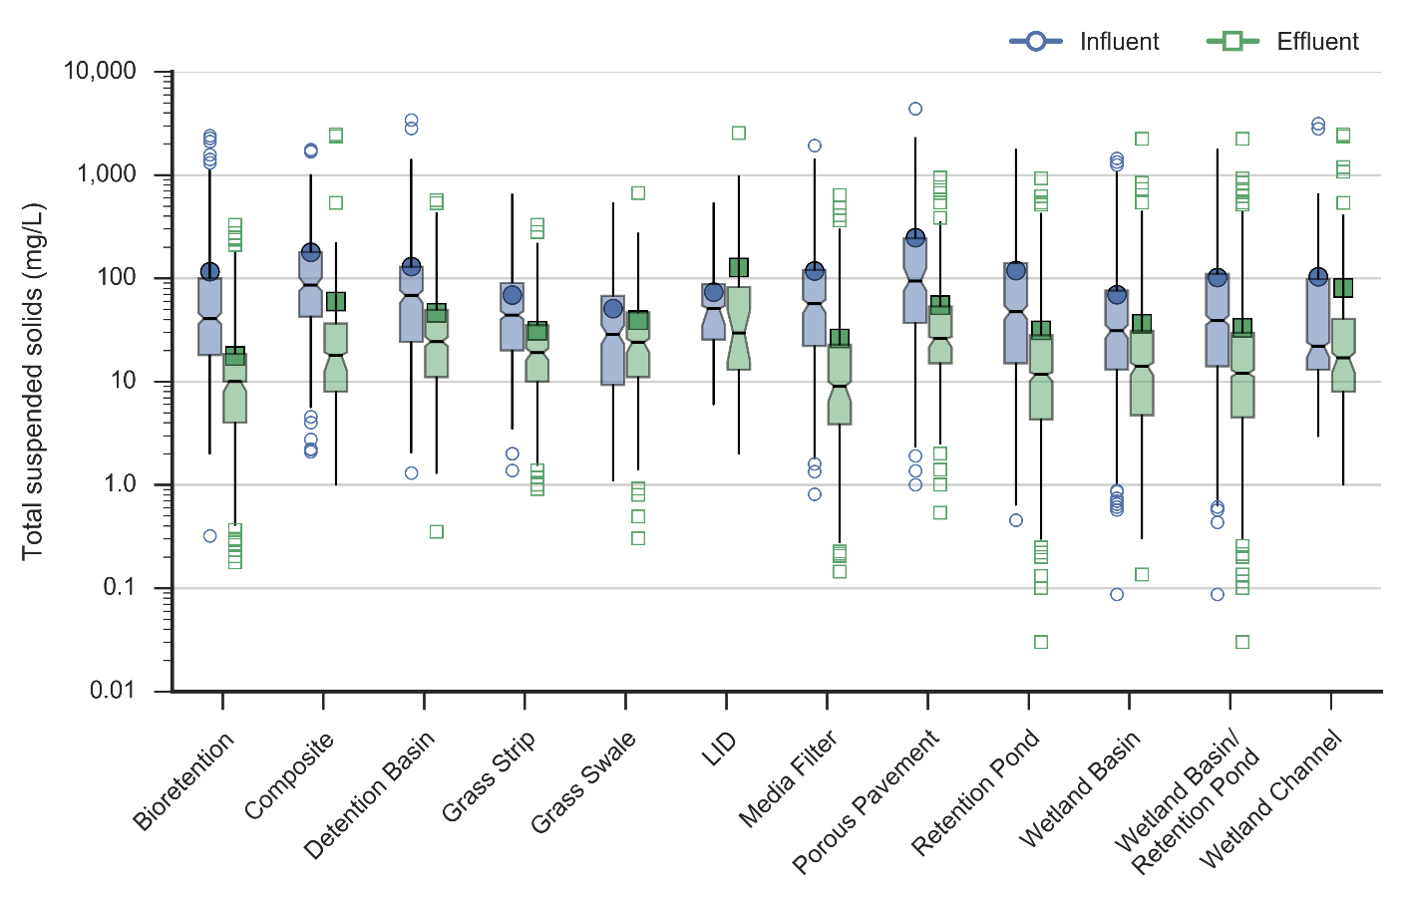

Figure 2-1. BMP Performance Boxplots for Total Suspended Solids (Wright Waters Engineers and Geosyntec Consultants 2016)

End Read More

#### Information Available to the Public

Read More The BMPDB project website (<http://www.bmpdatabase.org>) provides consolidated access to a variety of guidance and interpretive reports related to BMP water quality performance, in addition to access to the BMPDB itself. For example, monitoring guidance, recommendations for statistically sound approaches for performance analysis, reporting protocols (e.g., data entry spreadsheets and user’s guide), on-line statistical analysis tools, presentations, and summary reports are freely available and accessible to the public on the website. Pollutant summary reports have generally focused on analyzing solids, nutrients, metals, and bacteria for the most commonly monitored and reported BMP types. These include:

* Grass strips
* Bioretention
* Bioswales

| Category | Description | Number |
| --- | --- | --- |
| BR | Bioretention | 58 |
| CO | Composite—Overall Site BMP | 29 |
| DB | Detention - Underground Vault, Tank or Pipe(s) | 3 |
| DB | Detention Basin (Dry) - Concrete or Lined Tank/Basin With Open Surface | 4 |
| DB | Detention Basin (Dry) - Surface Grass-Lined Basin | 46 |
| GR | Green Roof | 17 |
| GS | Biofilter - Grass Strip | 45 |
| GS | Biofilter - Grass Swale | 44 |
| IB | Infiltration Basin | 2 |
| LD | Low Impact Development-Site Scale | 10 |
| MD | Manufactured Device | 113 |
| MF | Filter - Combination of Media or Layered Media | 3 |
| MF | Filter - Geotextile Fabric Membrane (Vertical) | 1 |
| MF | Filter - Other Media | 5 |
| MF | Filter - Peat Mixed With Sand | 2 |
| MF | Filter – Sand | 30 |
| MP | Maintenance Practices - Catch Basin Cleaning | 8 |
| MP | Maintenance Practices - Street Sweeping | 21 |
| OT | Other--Uncategorized BMP | 6 |
| PP | Permeable Friction Course | 6 |
| PP | Porous Pavement - Modular Blocks | 20 |
| PP | Porous Pavement - Pervious Concrete | 11 |
| PP | Porous Pavement - Porous Aggregate | 1 |
| PP | Porous Pavement - Porous Asphalt | 10 |
| PT | Infiltration (Dry) Well | 1 |
| PT | Infiltration (Percolation) Trench | 12 |
| RP | Retention Pond (Wet) - Surface Pond With a Permanent Pool | 75 |
| RP | Retention Underground Vault or Pipes (Wet) | 3 |
| RW | Rainwater Harvesting | 1 |
| WB | Wetland - Basin with Open Water Surfaces | 35 |
| WB | Wetland - Basin without Open Water (Wetland Meadow Type) | 4 |
| WC | Biofilter - Wetland Vegetation Swale | 4 |
| WC | Wetland - Channel with Wetland Bottom | 19 |
| **Total BMPs** | | **649** |
| CX | Control—No BMP/Control Site (for comparison) | 30 |
| **Total Data Sets** | | **679** |
| **Table 2-6.** BMPs in the International Stormwater BMP Database as of 2016 | |  |

***Table 2-6. BMPs in the International Stormwater BMP Database as of 2016***

EndRead More

## Information Needed to Use this Chapter

It is important when selecting a BMP to determine the land use type, soil type, the pollutants to be controlled, topography, receiving waters, and drainage area. A Survey by ITRC in early 2017 surveyed ITRC States. Responses to this survey identified specific pollutants (link to Question 2 in Appendix A) and site characteristics as important to their Storm water program (Figure 3-1).

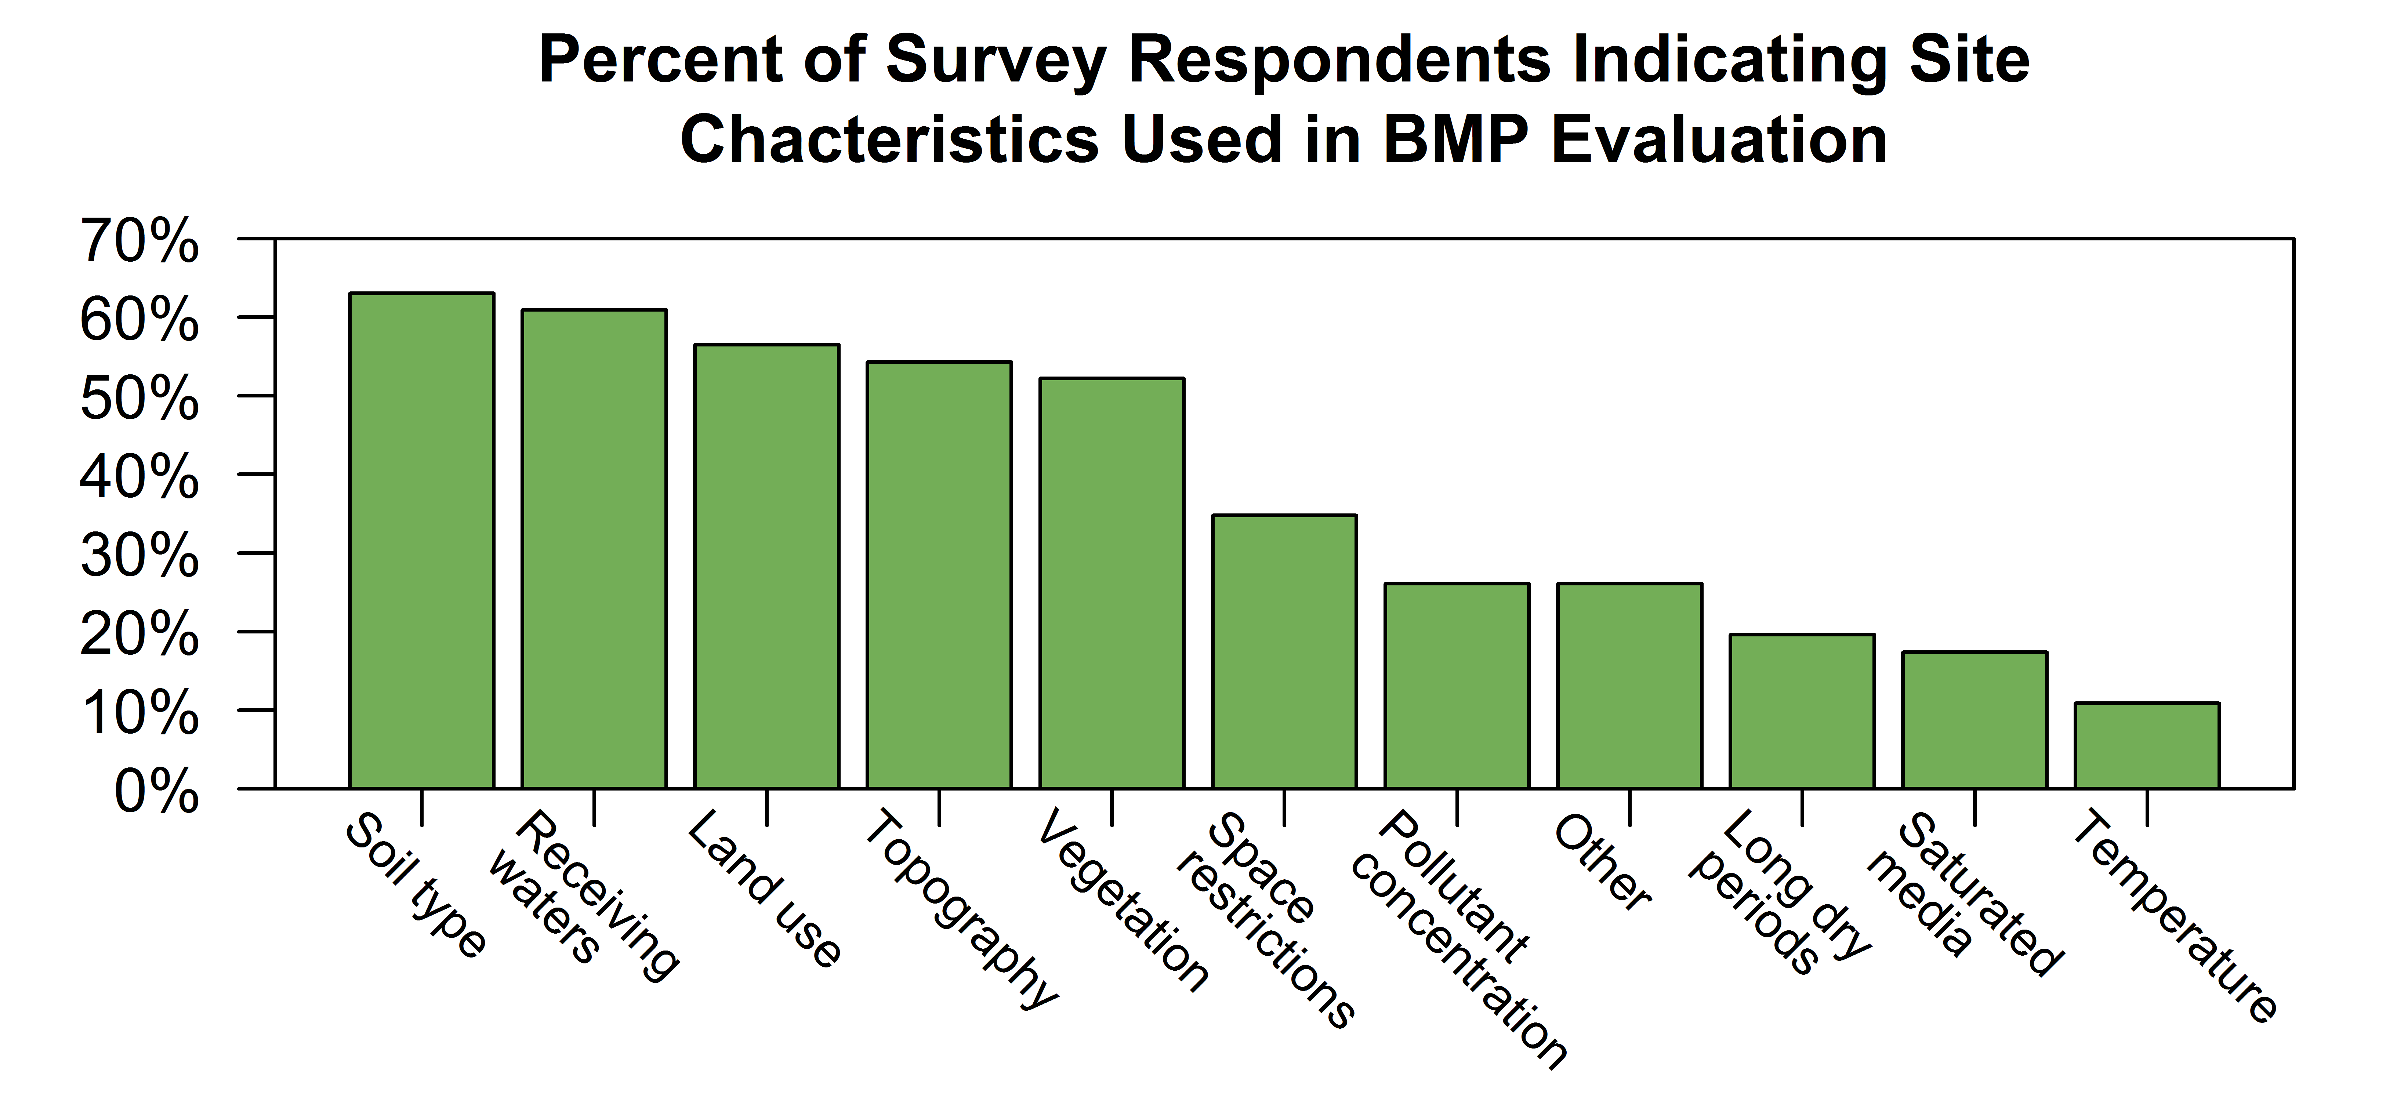

**Figure 3-1: Site characteristics important to the state, local and regional authorities surveyed in 2016. See** link to **Question 2 in Appendix A for additional details.**

Land use describes the human use of land. Land use represents the economic and cultural activities (e.g., agricultural, residential, commercial, and industrial, mining and recreational uses) practiced at a location. Designers must determine the land use prior to the selection of a BMP since land use will influence scope and activity. Current and future land use is influenced by geographic factors and may control or regulate the mitigation of pollutants of potential concern. Examples of the land uses include agricultural, residential, commercial, light and heavy industrial. Land use affects, but does not solely determine, the pollutants and runoff rates and quantity. For instance, in an area with agricultural land use, it may be a good practice to include vegetative buffers to capture the nitrate and phosphate contaminants typically found in fertilizer

The attached checklist (Table 4-1 (USEPA 1997)) is provided as an example to assist in the QA/QC of installed BMPs and is not applicable to all sites or BMP types. The checklist is a minimum guidance for BMP installation, identifying issues that can occur and/or must be addressed during the pre-construction, construction, and final stabilization phases of the project. This checklist is one of many, with additional example resources as follows:

|  |  |  |  |  |  |  |  |  |  |  |  |
| --- | --- | --- | --- | --- | --- | --- | --- | --- | --- | --- | --- |
| **TABLE 4-1. Stormwater Best Management Practice Installation Inspection Checklist** | | | | | | | | | | | |
| **Project Title:** | | | | | | | | | | | |
| **Permit/Plan Number:** | | | | | | **Owner Name:** | | | | | |
| **Inspector Name and Company:** | | | | | | **Contractor Name:** | | | | | |
| **Inspector Contact Information:** | | | | | | | | | | | |
| **PRECONSTRUCTION EFFORT** | | | | | | | | | | | |
| Preconstruction site photographs collected of BMP areas of impact: | | | | | | | | | | | Yes/No |
| If so, photograph log name: | | | | | | |  | | | | |
| BMP installation responsibilities contractually defined: | | | | | | | Yes/No | | | | |
| Expertise required for BMP installation: | | | | | | | Yes/No | | | | |
| If so, expertise contracted and scheduled: | | | | | | | Yes/No | | | | |
| Communication expectations established for the following: | | | | | | | | | | | |
| Changes in BMP design: | | | | | | | Yes/No | | | | |
| Installation requirements not specified in design: | | | | | | | Yes/No | | | | |
| Material requirement not specified in design: | | | | | | | Yes/No | | | | |
| Upstream conditions inspected for impact to BMP: | | | | | | | Yes/No | | | | |
| Diversion methods defined to minimize impact during construction: | | | | | | | | | Yes/No | | |
| **CONSTRUCTION EFFORT** | | | | | | | | | | | |
| **Weather Conditions:** | | | | | **Inspection Date and Time:** | | | | | | |
| **Antecedent Dry Period:** >72 hours 48-72 hours 24-48 hours <24 hours | | | | | | | | |  | | |
| **BMP Name:** | | | | | | | | **Photograph Number:** | | | |
| **BMP Location:** | | | | | | | | | | | |
| Required inspection frequency met: | | | | | | | | | Yes/No | | |
| BMP protection established and in good condition: | | | | | | | | | Yes/No | | |
| BMP meets design requirements: | | | | | | | | | Yes/No | | |
| Design modification required? | | | | | | | | | Yes/No | | |
| If yes, approving person name and date: | | | | | | | | | | | |
| Is maintenance required: | | | | | | | | | Yes/No | | |
| If yes, specify the following: | | | | | | | | | Yes/No | | |
| Required action: | | | |  | | | | | | | |
| Responsible party: | | | |  | | | | | | | |
| Due date: | | | |  | | | | | | | |
| **FINAL STABILIZATION EFFORT** | | | | | | | | | | | |
| BMP installed per design with no impact from construction activities | | | | | | | | | Yes/No | | |
| BMP free of debris and sediment: | | | | | | | | | Yes/No | | |
| Was the upstream conveyance system free of debris and sediment: | | | | | | | | | | Yes/No | |
| Was the design altered? | | | | | | | | | | Yes/No | |
| If yes, was a Record Drawing prepared and submitted? | | | | | | | | | | Yes/No | |
| Post-construction site photographs collected of BMP areas of impact: | | | | | | | | | | Yes/No | |
| If so, photograph log name: | | |  | | | | | | | | |
| For short-term maintenance: | | | | | | | | | | | |
| Schedule established: | | | | | | | | | Yes/No | | |
| Responsible party: | |  | | | | | | | | | |
| Contract executed: | | | | | | | | | Yes/No | | |
|  | | | | | | | | | | | |
| Signature of Inspector: |  | | | | | | | | | | |

## Routine Monitoring and Maintenance

Although routine maintenance is performed independent of inspections, it is important to keep records of maintenance activities. Approximately half of the agencies surveyed require maintenance documentation for MS4 and Industrial Stormwater BMPs (Figure 5-2). Records of specific routine maintenance activities performed over a range of BMPs provide feedback to refine the maintenance schedule and ensure that BMPs in problem areas receive necessary attention. Records help assess the level of effort in maintaining BMPs to ensure efficient use of time and resources. Records showing recurring maintenance activities may indicate an ongoing problem or failure of a BMP component that requires a higher level of effort than is provided by routine maintenance. For example, a bioretention basin with records showing the need for additional material to level the media could indicate a slow collapse of the underdrain system. With this information, a more extensive investigation of the BMP, and changes, can be made to correct the deficiency before a total failure occurs.

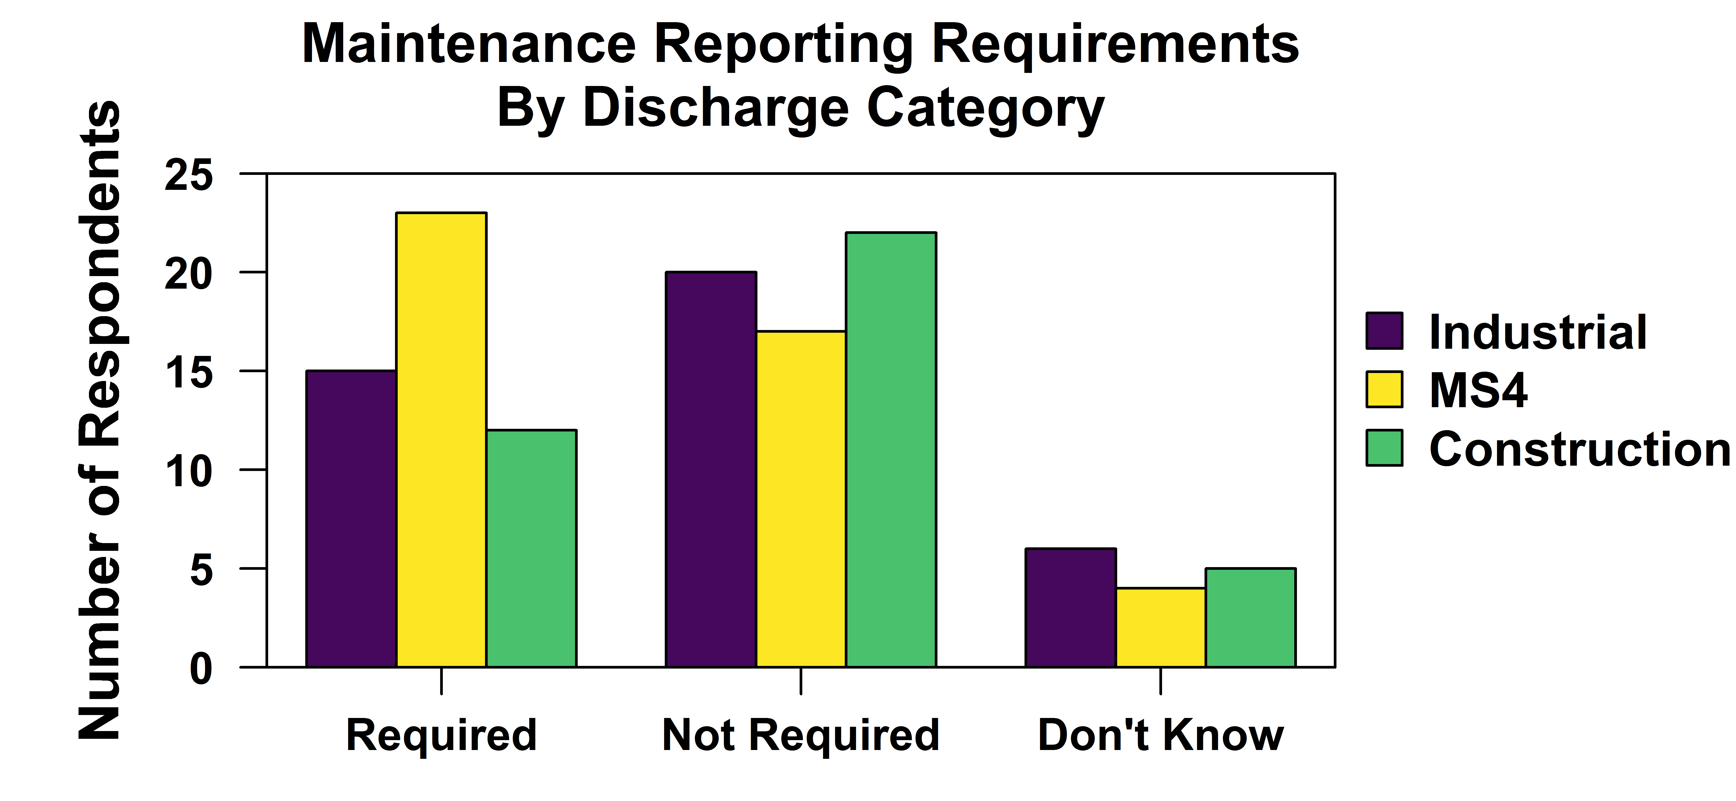

**Figure 5-2. Survey Responses to survey question, “Does your Agency have mandatory maintenance reporting requirements for post construction BMP performance? For more information see Appendix A)**

Post construction monitoring requirements vary widely across jurisdictions. Survey respondents indicated that monitoring primarily occurs through routine agency inspections, and permit required self-reporting (Figure 5-1). These are all examples of routine monitoring.

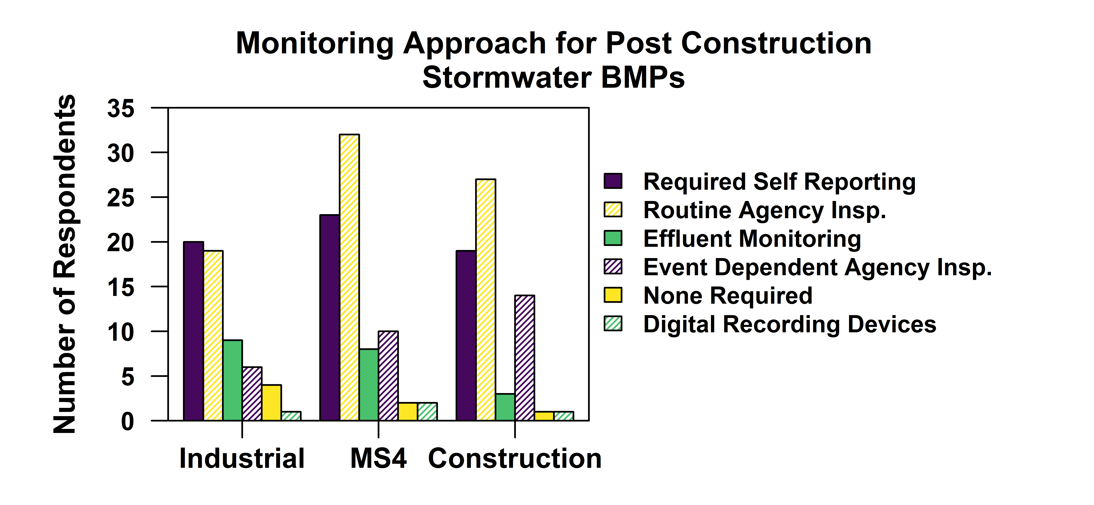

## Non-routine Maintenance

Non-routine maintenance results from an observation made in an inspection or maintenance report or from a complaint about a failure. Non-routine maintenance are corrective measures that occur on an as-needed basis. These include repair to inlet or outlet structures, repair to eroded slopes embankments or flow paths, replacement of filter media that is no longer effective, and removal of accumulated sediment and replacement of dead plantings. Non-routine maintenance usually requires specialized training for maintenance staff. Special equipment for excavation, compaction, and drainage infrastructure installation may be required for more extensive repairs. The most protective maintenance programs utilize routine proactive measures to address operational needs and non-routine reactive measures to address unforeseen issues.

## 5.4 Technology vs Performance-based Strategies

Stormwater BMPs are designed and constructed to meet specific stormwater management goals related to water quality or quantity. These goals are met by applying either performance-based criteria or technology-based criteria. A performance-based strategy demonstrates compliance with a stormwater management goal by focusing on the discharge or output from a BMP and verifies that the discharge meets or exceeds that goal. In contrast, a technology-based strategy focuses on the physical characteristics of the BMP, in its specific operating environment and demonstrates compliance by conforming to design standards set by the stormwater management program. Prior research, testing and experience with the BMP standard design provides assurance that the management goal will be met and analysis of the discharge from the BMP is not necessary. The concepts of performance and technology-based criteria can be applied to operation and maintenance situations as well.

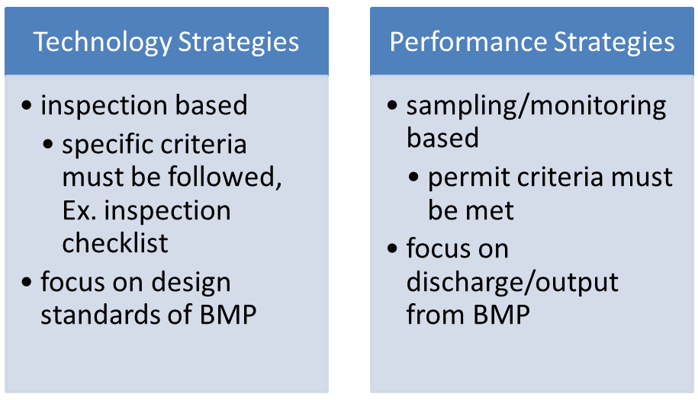

Many non-routine maintenance actions occur because of some failure in the operation of the BMP and are therefore considered performance-based strategies. For example, a citizen reports water pooling for extended periods of time in a bioretention filter. This report results in an investigation and maintenance, or repair to the facility, based on the observed failure in the BMP performance or function. All of the other aspects of the bioretention filter may look fine, but some problem is causing a failure in performance that leads to the necessary maintenance activity.

#### Waste Characterization and Disposal Cost Factors

*Read more* One of the most common long-term maintenance activities is sediment, media or accumulated pollutant removal. Almost half of survey respondents indicate BMP sediment management disposal strategies and guidance are being addressed (Figure 5-3).

**Figure 5-3. Responses to ITRC Survey Question 9 (Additional Detail can be see in Appendix A)**

In addition to the costs associated with mobilization and actual dredging or other removal actions, the waste (including sediment) generated from the removal must be characterized (tested) and properly disposed of, both of which add cost to the maintenance activity. The scope of testing needed to determine appropriate disposal methods will vary. Survey Results indicate a variety of characterization methodologies (Figure 5-4).

**Figure 5-4. State Survey Question # 10 “How is Storm water pond sediment characterized for disposal in your state or municipality?” (See Appendix A for more information)**

At a minimum, the Toxicity Characteristic Leaching Procedure (TCLP) should be used to determine if a waste should be characterized as a hazardous waste due to toxicity by simulating the conditions it would be exposed to in a landfill. Hazardous wastes must be disposed of at a facility authorized to accept such wastes. Current and previous land uses within the watershed will provide insight into additional constituents that may need to be evaluated to ensure proper disposal. For example, a BMP that drains roadways or parking areas may receive significant loadings of petroleum hydrocarbons or other related constituents. BMPs located in residential or heavily landscaped areas may have concentrations of pesticides or herbicides within their sediments or other media that require special handling. Sediments or other media within BMPs that drain industrial operations may need evaluation for constituents specific to those operations. Landfills and dredge material disposal facilities may have contaminant concentration limits on the waste that they can accept. In addition, state agencies may have set contaminant concentration limits for sediment that can be reused as fill or spread over land (See (Quality 2012). However, based on survey responses further development is needed for guidance on pollutant characterization and disposal for BMP sediments (Figure 5-5).

**Figure 5-5. Responses to ITRC Survey Question 8.**

The extent of contamination of sediment or media to be disposed of will impact disposal costs. If on-site disposal is prohibited, transportation and disposal facility costs should be factored into cost estimates. End read more

Pending development

APPENDIX A ITRC Survey Results (Pending)

Appendix B: Installation Checklists

|  |  |
| --- | --- |
| Additional Links To Installation Inspection Checklists | |
| http://rrstormwater.com/sites/default/files/documents/Stormwater%20Structural%20BMP%20Inspection%20Checklists.pdf | Metropolitan Nashville - Davidson County (Nashville 2013) |
| <https://www.como.gov/PublicWorks/Engineering/documents/bmp_inspectionform.pdf> | City of Columbia, Missouri (Missouri 2017) |
| http://www.scvurppp-w2k.com/bmp_om_forms/PublicInspectChklstAll.pdf | Santa Clara Valley, CA (Valley Not Specified) |
| https://www.lrrb.org/PDF/2009RIC12.pdf | Minnesota DOT (Transportation 2009) |
| http://www.epa.ohio.gov/portals/35/storm/CGP_Ins1.pdf | Ohio EPA (EPA 2014) |
| http://stormwatercenter.colostate.edu/resources/ | Colorado Stormwater Center (Center 2017) |
| http://stormwatercenter.colostate.edu/wp-content/uploads/2015/06/BMP-IM-Field-Guide.pdf | Colorado Stormwater Center (Center 2015) |
| <https://www3.epa.gov/npdes/pubs/sw_swppp_inspection_form.doc+&cd=11&hl=en&ct=clnk&gl=us> | USEPA Inspection (USEPA 2007) |
| http://hidot.hawaii.gov/harbors/files/2013/01/2014-Post-Construction-SW-Manual_FINAL.pdf | HI DOT 2014 Post Construction SW Manual_FINAL (Transportation 2014) |
| http://www.richmondgov.com/dpu/documents/BMPQuality_Infiltration_Practices_Inspection_Checklist.pdf | City of Richmond, VA (Richmond no given) |
| http://www.fairfaxcounty.gov/dpwes/forms/spec-11-wet-swales.pdf | Fairfax County, VA (County none given) |